Township of Raritan Town Clerks Office 1 Municipal Drive  Flemington, NJ 08822  (908) 806-6101 | Raffles & Bingo

This packet has been designed to assist registered organizations with the games of chance process and is meant to be used as a guide. Only organizations that have registered and have been issued a Registration Certificate (ID card) by the New Jersey Legalized Games of Chance Control Commission are eligible to conduct games of chance.
The New Jersey Legalized Games of Chance Control Commission has full authority over games of chance. It is important to visit the website for Legalized Games of Chance for current information. A list of links and
contact information is provided below.
You may also contact the Raritan Township Clerk’s Office at (908) 806-6101 for further assistance when applying for games of chance licenses. License applications and other required forms are also included in this packet.

Legalized Games of Chance Control Commission Contact Information and Important Links

Contact Information
Legalized Games of Chance Phone Number | (973) 273-8000
Legalized Games of Chance Mailing Address | PO Box 46000  Newark, NJ 07101
Legalized Games of Chance Physical Address | 124 Halsey Street  Newark, NJ 07102

Website Links
Home Page | www.njconsumeraffairs.gov/lgccc/pages/default.aspx
LGCCC Registration Information | www.njconsumeraffairs.gov/lgccc/Pages/registration.aspx
LGCCC Application and Forms | http://www.njconsumeraffairs.gov/lgccc/Pages/applications.aspx
Laws and Regulations | http://www.njconsumeraffairs.gov/lgccc/Pages/regulations.aspx
LGCCC Fees | http://www.njconsumeraffairs.gov/lgccc/Pages/licensefees.aspx
Registered Organizations, Licensed Dealers,  Licensed Equipment Providers | http://www.njconsumeraffairs.gov/lgccc/Pages/Registered-Organizations.aspx

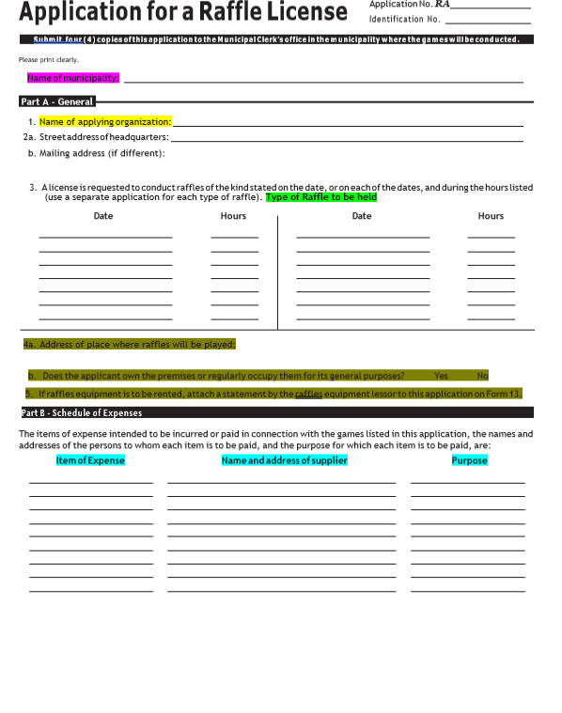
Enter Type of
Raffle Here
Example: Tickets
Left over supply
OR Name of Printer
Draw

Enter “Raritan Township” in this section. If the game/raffle is not being conducted in Raritan Township, you must apply with the municipality in which the game/raffle will be held.

Applications need to be submitted in triplicate (3).
Part A/Item 1: Enter name of the organization, which must match
exactly to the name on the Registration Certificate/ID card issued by the Legalized Games of Chance Control Commission.
Part A/Items 2a and 2b: Enter the street address of organization and mailing address if different than street address.
Part A/Item 3: Enter the date and hours in which the raffle will be held.
Also indicate the “Type of Raffle” below date, for example "Off-Premise
50/50," "On-Premise Merchandise Raffle," etc. Please see
raffle type/fee schedule for raffle types, which is included in this packet.

On-Premise Raffle: Winner is present and tickets are sold at the location of the event only.
OFF-Premise Raffle: Winner is not required to be present at the time
of drawing, and a “Sample Ticket” is required for Off Premise Raffles.
Part A/Item 4a: Enter the address where the raffle will be held. This
address must be located in the TOWNSHIP OF RARITAN.

Part A/Item 4b: Indicate whether the applicant owns the premises where the raffle will be held, or if the applicant is a regular occupant.

Part A/Item 5: Include Form 13 for rented equipment , if applicable
(sample included).
Part B: Expense items are listed in this section.
Payments for prizes must be made PRIOR to the date of drawing
The expenses listed in this section must be goods, wares, or merchandise. SERVICES cannot be listed as an expense.

If your organization is renting equipment connection with the raffle, the vendor MUST be approved by the Legalized Games of Chance Control Commission. A list of approved vendors can be found on the LGCC website.
Applications must be originals.
Copies of signature or notary seal will not be accepted.

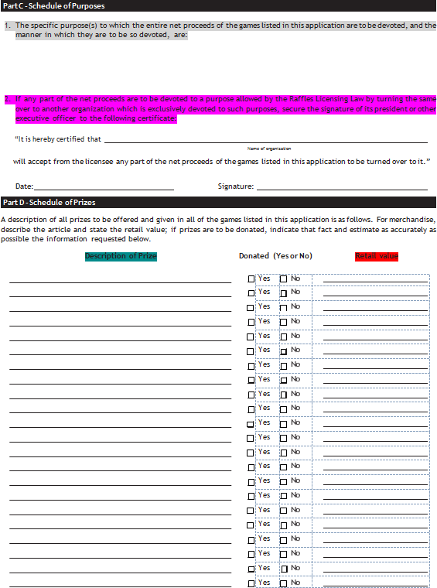

Part C/Item 2: If proceeds are to be donated to another organization, it should be entered in this section. The name of the benefiting organization and its President’s (or other executive officer’s) signature is required.

The organization entered in this section is only benefiting from the proceeds. Only the Organization that owns the State License is conducting the games, and officers listed on the fourth page should reflect that Organization. “Borrowing” of licenses and Registration Certificate/ID card is not permitted by LGCCC.

This information will also need to be noted appropriately in the Raffle Report of Operations. Failing to do so will result in future denial of raffle applications.

Part D-Description of prizes . If the raffle is a 50/50, Enter “50% of the proceeds”. You do not need to list all the prizes. Enter "No prohibited prizes will be awarded."

Be sure to review the list of prohibited prizes included in this packet to ensure that the prizes to be awarded are approved by the Legalized Games of Chance Control Commission.
Part D-Retail Value: Enter the ANTICIPATED value of prizes.

The raffle fee for each game of chance is determined by the anticipated and actual retail value of prizes awarded. Enter in "Estimated at $XXX"

If no amount is entered, the Legalized Games of Chance Control Commission will assume the highest value, resulting in a higher license fee for the applicant.

Part C/Item 1: Enter the purpose for which the proceeds are to be devoted in this section.

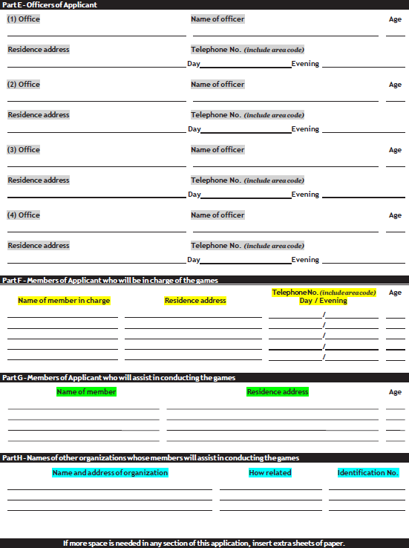

Part F: Enter the names of the members responsible for the raffle application, various reports, handling of the games, etc. Names should be listed in order of best contact and may be duplicative of members listed as the organization’s officers in Part E.

Part E: Enter the names, addresses, phone numbers and ages of the organization’s officers. These are the officers for the organization entered in Part A/Item 1.

Part G: If applicable, enter the names and addresses of the individuals that will assist in conducting the raffle. These names should also be listed in order of best contact and may be duplicative of members listed as the organization’s officers in Part E.

Part H: If applicable, enter the name of the organization that will be assisting in conducting the raffle.

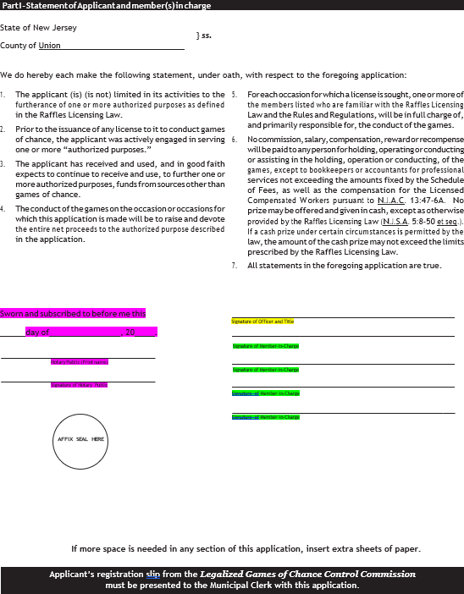
SAMPLE
==== Hunterdon

The signature of the Officer must be notarized.

An officer that was named in Part E MUST sign in this section and note their title. This signature indicates approval of the applicant’s Registration Certificate/ID card issued by the Legalized Games of Chance Control Commission. ALL SIGNATURES MUST BE ORIGINAL ON ALL THREE (3) COPIES OF THE RAFFLE APPLICATION.

The application requires two (2) signatures. At least ONE
Member in Charge entered in Part F must sign in this section.

Sample Ticket
Name
Address
State
Telephone Number
Off Premises Raffle Awarding Cash
N.J.A.C. 13:47-8.8

Stub Ticket
Ticket #
price of Ticket
purpose to which entire proceeds will be devoted
“No substitution of the offered prize may be made.”
Time of Drawing
Date of Drawing
Location of Drawing
Name of Organization

50/50
This is a 50/50 cash raffle and the winner will receive 50% of the amount received for all tickets or rights to participate.
Municipal RL #
NJ LGCCC Identification #
Ticket #
Zip code
Municipal RL #

This illustration is provided for your convenience. While the form of the ticket may vary, the information listed above must be contained on your printed ticket. If you require assistance with your ticket, please contact the office of Legalized Games of Chance Control Commission at (973) 273-8000. This sample ticket must be attached to the Application for Municipal Raffle License and submitted to the municipality.
City
NJ LGCCC Identification#

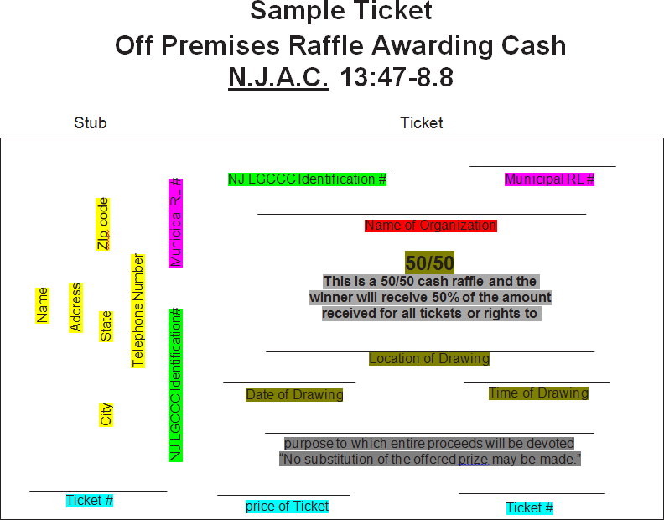

Insert ID number as it appears on Registration Certificate issued by LGCCC

Provided by the Township of Raritan once the raffle has been approved by LGCCC

Name must appear exactly as it appears on Registration Certificate (ID card issued by LGCCC)

This information must match the information provided on the raffle application.

These statements must be included on all Off Premise 50/50 Raffle Tickets

Indicate price of ticket and how tickets will be numbered

This information is completed by the purchaser of the ticket at the time of sale

Sample Ticket
SAMPLE
Name
Address
State
Telephone Number
Off Premises Merchandise Raffle
N.J.A.C. 13:47-8.7

Stub Ticket
Ticket #
Price of Ticket
Purpose to which entire proceeds will be devoted
“No substitution of the offered prize may be made and no cash will be given in lieu of the prize.”
Time of Drawing
Date of Drawing
Location of Drawing
Retail Values
List of Prizes
Name of Organization
Municipal RL #
NJ LGCCC Identification #
Ticket #
ZIP code
Municipal RL #

This illustration is provided for your convenience. While the form of the ticket may vary, the information listed above must be contained on your printed ticket. If you require assistance with your ticket, please contact the office of Legalized Games of Chance Control Commission at (973) 273-8000. This sample ticket must be attached to the Application for Municipal Raffle License and submitted to the municipality.
City
NJ LGCCC Identification#

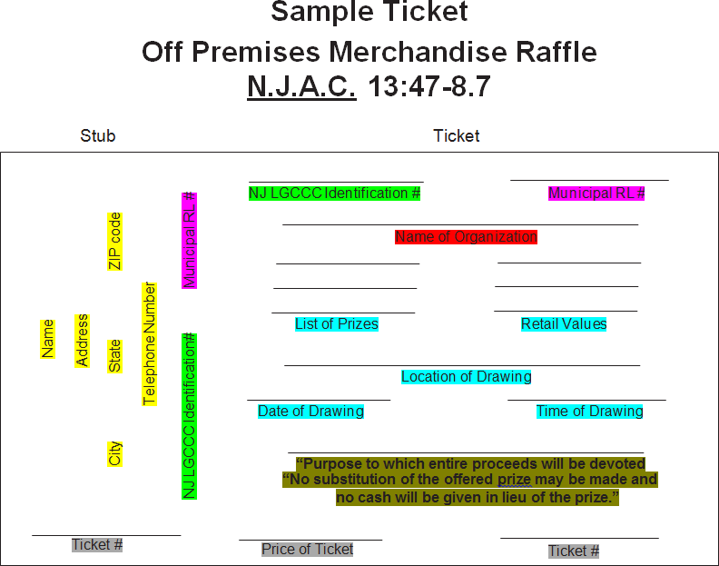

Insert ID number as it appears on Registration Certificate issued by LGCCC

Provided by the Township of Raritan once the raffle has been approved by LGCCC

Name must appear exactly as it appears on Registration Certificate (ID card issued by LGCCC)

This information must match the information provided on the raffle application

This statement must be included on all Off Premise Merchandise Raffle Tickets.

Indicate price of ticket and how tickets will be numbered

This information is completed by the purchaser of the ticket at the time of sale.

PROHIBITED PRIZES

PROHIBITED PRIZES [N.J.A.C. 13:47-6.20]

- Real estate or an interest therein;

- Bonds;

- Shares of stock;

- Securities or evidences of indebtedness;

- Weapons;

- Live Animals (except a gift certificate redeemable for live, edible seafood);

- Foreign or domestic coins (except collector pieces or sets that are marketed as such and are clearly not intended for use as legal tender);

- Tobacco products;

- Motor vehicle leases or any merchandise refundable in any of the above or as money or cash.

- No prize consisting of cash or money shall be offered or awarded except in the case of:

  - A raffle conducted by a drawing with the prize(s) equaling fifty percent (50%) of the amount received for all tickets or right to participate, a calendar raffle with the maximum prize amount not to exceed
$25,000.

  - Any bingo game(s) conducted in accordance with the provisions of this chapter and Bingo Licensing Law; or

  - Big six wheels and horse race wheels conducted in accordance with the provisions of N.J.A.C. 13:47-8.

  - An instant raffle game having a maximum prize amount of $1,500 for any one ticket conducted in accordance with the provisions of N.J.A.C. 13:47-8.

TOWNSHIP OF RARITAN RAFFLE FEES

The Legalized Games of Chance has the right to update fees at their discretion. This list is a guide to the fees due. Please confirm fees on the State Website. If you do not see the game of chance listed below, please reference the LGCCC website for additional games and corresponding fees http://www.njconsumeraffairs.gov/lgccc/Pages/licensefees.aspx

Raffle Type | Off/On Premise  Off Premise- Winner does not need to be present to claim prize  On Premise- Winner needs to be present to claim prize | State Fee  Submitted at Time of Application | Additional Notes | Township of Raritan  Fee
50/50 | On Premise | $20.00 per day IF the anticipated prize(s) to  be awarded is in excess of $400. No fee if anticipated prize(s) is below $400. | $20.00 per day IF prize(s) is in excess of $400 to be submitted to the LGCCC and the Township. | Same as State Fee
50/50 | Off Premise | $20.00 for each $1,000 or part thereof in value of the anticipated awarded prize. Sample ticket required. |  | Same as State Fee
Merchandise Raffle | On Premise | $20.00 per day IF the retail value of the prize(s) to be awarded is over $400. No fee if total retail value of prize(s) is below $400. |  | Same as State Fee
Merchandise Raffle | Off Premise | $20.00 for each $1,000 or part thereof of the total retail value of the prize(s) to be awarded. Sample ticket required. |  | Same as State Fee
Non Draw Raffle  Big Wheel, Nonprofit Carnival Games | N/A | $20.00 for each game or wheel held on any one day. Form 13 required from an authorized state supplier of equipment. |  | Same as State Fee
Bingo | N/A | $20.00 for each occasion. Form 13 required from an authorized state  supplier of equipment. |  | Same as State Fee
Duck Race | N/A | $20.00 for each $1,000 or part thereof of the total retail value of the prize(s) awarded. |  | Same as State Fee
Calendar Raffle | N/A | $20.00 for each $1,000 or part thereof of the total retail value of the prize(s) awarded. Sample calendar required. |  | Same as State Fee
Instant Raffle Game  or Pull Tabs | N/A | $20.00 for each day on which instant raffle tickets are sold or offered for sale, or $750 for a one-year license to sell, or to offer for sale, instant raffle tickets during that year. | Must provide the name of a state-licensed equipment provider. No form 13 required. | Same as State Fee

Raffle Type | Off/On Premise  Off Premise- Winner does not need to be present to claim prize  On Premise- Winner needs to be present to claim prize | State Fee  Submitted at Time of Application | Additional Notes | Township of Raritan  Fee
Casino Night | N/A | $100.00 per occasion (Form 13 required) |  | Same as State Fee
Golf Hole-in-One Contest | N/A | $20.00 per day for each $1,000 or part thereof of the retail value of the prize(s) to be awarded |  | Same as State Fee
Armchair Race | N/A | $50.00 per occasion. (Form 13 required) |  | Same as State Fee
Special Door Prize | N/A | No license or fee required provided the merchandise is wholly donated with the prize(s) total retail value below $50, and no other raffle is being conducted |  | Same as State Fee

New Jersey Office of Attorney General
Division of Consumer Affairs
Legalized Games of Chance Control Commission
124 Halsey Street, 6th Floor, P.O. Box 46000 Newark, New Jersey 07101
(973) 273-8000

Instructions for Filing the Raffle Report of Operations

Pursuant to N.J.A.C. 13:47-9.1, licensees must file a report of operations with the Legalized Games of Chance Control Commission no later than the 15th day of the calendar month immediately following the calendar month in which the licensed activity was held, operated or conducted.

You must download this report and complete ALL of the entries for each occasion(s) relating to the conduct of all raffles, except for instant raffle games and carnival games and wheels. Once completed, a member/officer must certify that he/she has reviewed the report and that the information provided is true, accurate and complete. This will require the person to state his/her name and title, and that person must complete the information on page 3 and have the report notarized.

The Raffle Report of Operations for the conduct of off-premises 50/50 or merchandise raffles is to be accompanied with a sample ticket. Reports are to be mailed to Legalized Games of Chance Control Commission, P.O. Box 46000, Newark, New Jersey 07101, or emailed to PetermanA@dca.lps.state.nj.us .

It is recommended that you maintain a copy of all reports as part of the organization’s records.

New Jersey Office of Attorney General
Division of Consumer Affairs
Legalized Games of Chance Control Commission
124 Halsey Street, 6th Floor, P.O. Box 46000 Newark, New Jersey 07101
(973) 273-8000

Raffle Report of Operations

Please print clearly. Identification number

Municipality License number
Name of licensee
Organization

Street address City State ZIP code

Location of games

This report, as required by N.J.S.A. 5:8-37 and N.J.A.C. 13:47-9, must be filed with the Legalized Games of Chance Control Commission no later than the 15th day of the month following the conduct of the game(s) of chance.
Occasion 1 Date Time Type of raffle
- Number of tickets sold 4. Cost of prizes $ Type of prize(s)
- Ticket price $ 5. Supplies/Equipment cost $
- Gross receipts $ 6. Other expenses $
7. Total expenses $ 8. Net proceeds $

Occasion 2 Date Time Type of raffle
- Number of tickets sold 4. Cost of prizes $ Type of prize(s)
- Ticket price $ 5. Supplies/Equipment cost $
- Gross receipts $ 6. Other expenses $
7. Total expenses $ 8. Net proceeds $

Occasion 3 Date Time Type of raffle
- Number of tickets sold 4. Cost of prizes $ Type of prize(s)
- Ticket price $ 5. Supplies/Equipment cost $
- Gross receipts $ 6. Other expenses $
7. Total expenses $ 8. Net proceeds $

Occasion 4 Date Time Type of raffle
- Number of tickets sold 4. Cost of prizes $ Type of prize(s)
- Ticket price $ 5. Supplies/Equipment cost $
- Gross receipts $ 6. Other expenses $
7. Total expenses $ 8. Net proceeds $

Occasion 5 Date Time Type of raffle
1. Number of tickets sold |  | 4. Cost of prizes | $ Type of prize(s)
2. Ticket price | $ | 5. Supplies/Equipment cost | $
3. Gross receipts | $ | 6. Other expenses | $
 |  | 7. Total expenses | $ 8. Net proceeds $

Occasion 6 Date Time Type of raffle

1. Number of tickets sold |  | 4. Cost of prizes | $ Type of prize(s)
2. Ticket price | $ | 5. Supplies/Equipment cost | $
3. Gross receipts $ 6. Other expenses $ ^{(If} ^{needed,} ^{attach} ^{separate} ^{sheet)}
7. Total expenses $ 8. Net proceeds $

Total number of occasions ..................................
Total number of tickets sold (1-6 combined) ......
Price of tickets..................................................... | $
Total gross proceeds (1-6 combined) .................. | $
Total expenses (1-6 combined) ........................... | $
Total net proceeds (1-6 combined)...................... | $

Schedule of Expenses

Date | Description | Check number | Amount

Utilization of Net Proceeds

Date | Description | Check number | Amount

Bank

Name | Address where balance is deposited | Account number

Person Responsible for Use of Proceeds

Name | Address | Telephone number  (include area code)
I certify that all of the statements on this report of operations are true, accurate and complete. I am aware that if any of the foregoing statements are willfully false, I am subject to punishment.

Prizes Offered or Awarded
Please list the prizes offered or awarded and their respective retail values.
Prizes Offered or Awarded | Retail Value

Prizes Offered or Awarded | Retail Value

N.J.S.A. 5:8-37 “It shall be the duty of each licensee to maintain and keep such books and records as may be necessary to substantiate the particulars of each such report.”

I certify that I have reviewed this report and that the information on this report of operations is true, accurate and complete. I am aware that if any of the foregoing statements are willfully false, I am subject to punishment.

I certify by placing a check in this box, that I have reviewed the report and that the information provided is true, accurate and complete.

You must state your name and title below. Reports that are not properly certified will be emailed back.

Name and title of officer (please print) Signature of officer

Sworn and subscribed to before me this

Affix Seal Here
day of ,
Month Year

Name of Notary Public (please print)

Signature of Notary Public

Form LGCCC 8R-A (Rev. 4/6/16)

